

**Submitted by: Submitted to:**

**NAME: Rahul Gusain Dr. Hitesh Kumar Sharma**

**SAP: 500084143**

**ROLL NO.: R214220900**

**BATCH: 1 DevOps**

# Build and Release Management

**LAB EXERCISE 10**

**Aim:** Integration using GitHub

Create a complete Maven project and push in GitHub repository for Continuous Integration.

**Step 1:-** First create a Maven project named “BRM_LAB_10”.

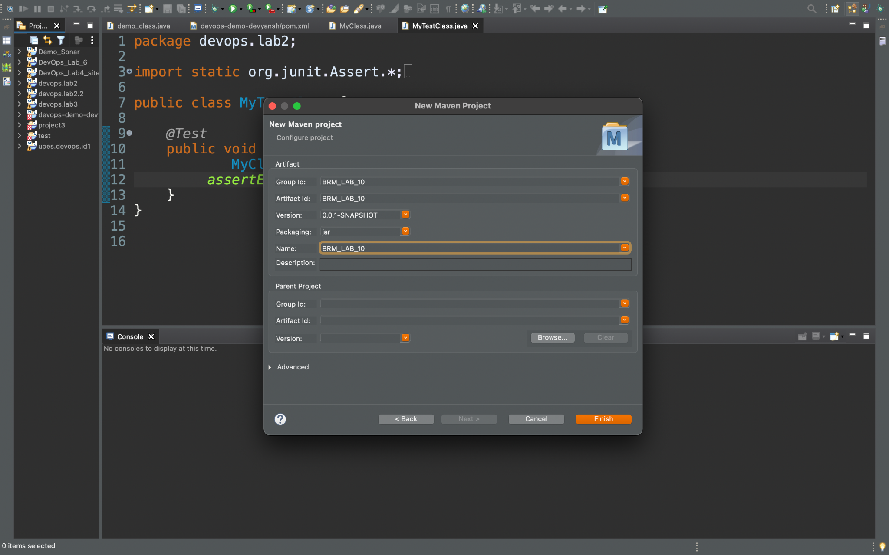

**Step 2:-** Now In that project create a class named as “MyClass”.

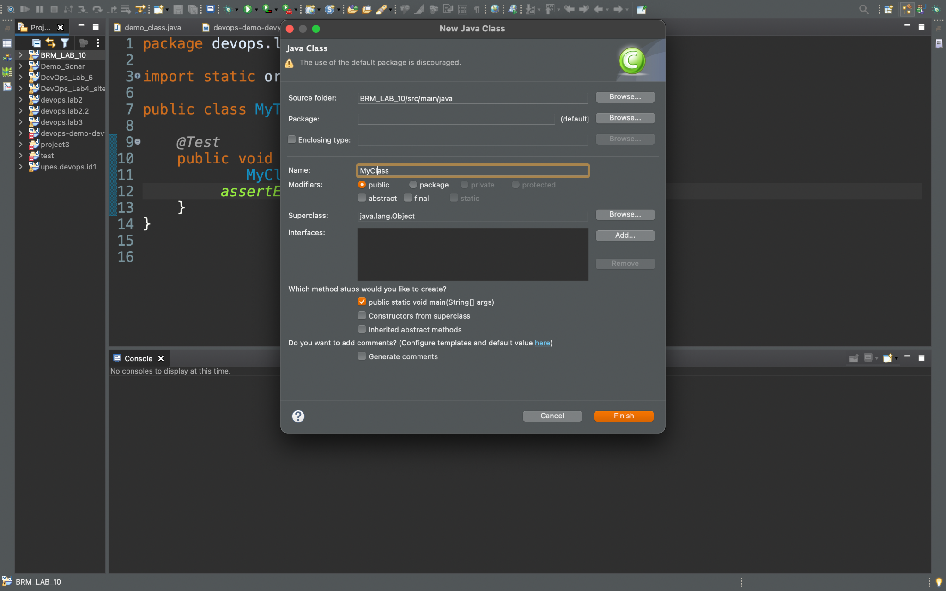

**Step 3:-** Now In that class print something on the console.

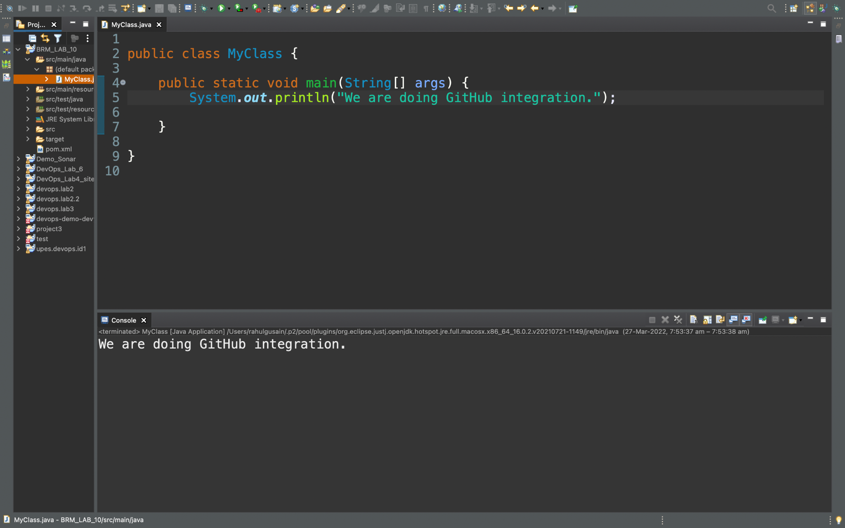

**Step 4:-** After that open, a GitHub account create a new repo and then generate tokens after that just pass a commit using eclipse.

